# Debugging Exercises

Name: Samnang Yorng  
Campus: Sydney

## Exercise 1: Run the Debugger

Run the Debugger Upload a screenshot of Visual Studio running in debug mode.  
Insert Screenshot

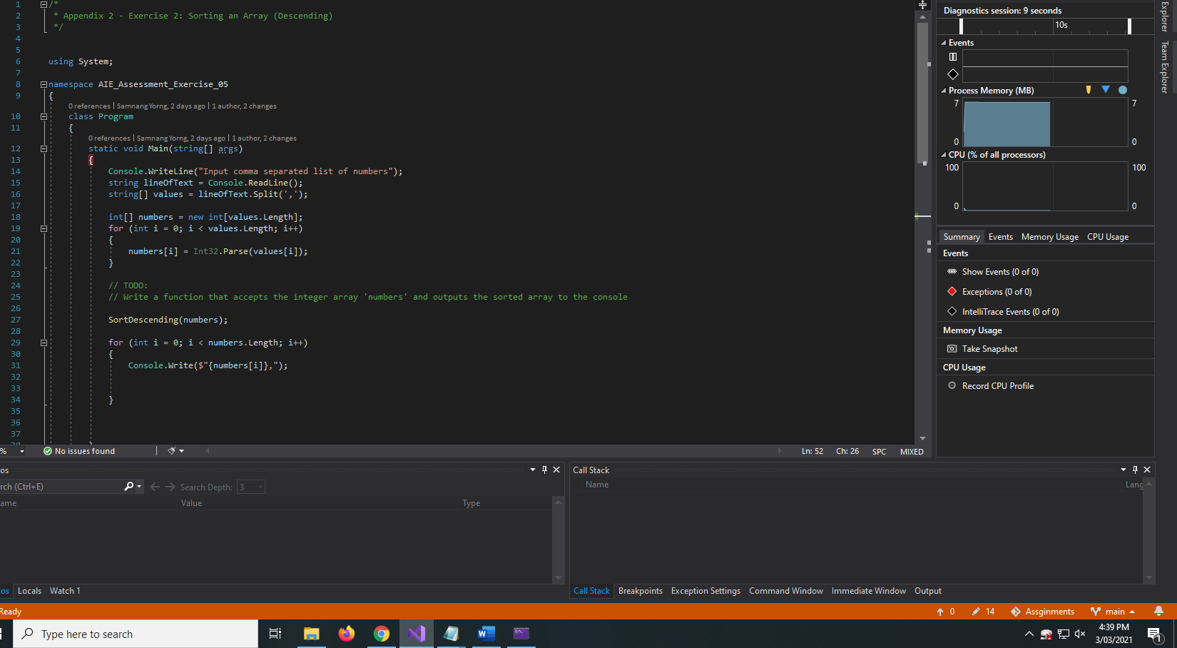

## Exercise 2: Compiler Errors

Upload a screenshot of 3 different compiler errors. Write a brief description of what each error means.

|  |  |
| --- | --- |
| **Screenshot** | **Error Description** |
|  | Forgot “;”.  Add “;” to fix |
|  | Cannot recognise tmp as an int.  To fix add “int” infront. |
|  | Error due to loop not recognising “numbers type“ missing .Length”  To fix replace numbers with “numbers.Leng |

## Exercise 3: Reference Material

List at least one website that provides material to aid you in understanding the C# Language.

<https://stackoverflow.com/>

## Exercise 4: Using the Debugger

Upload a screenshot showing.

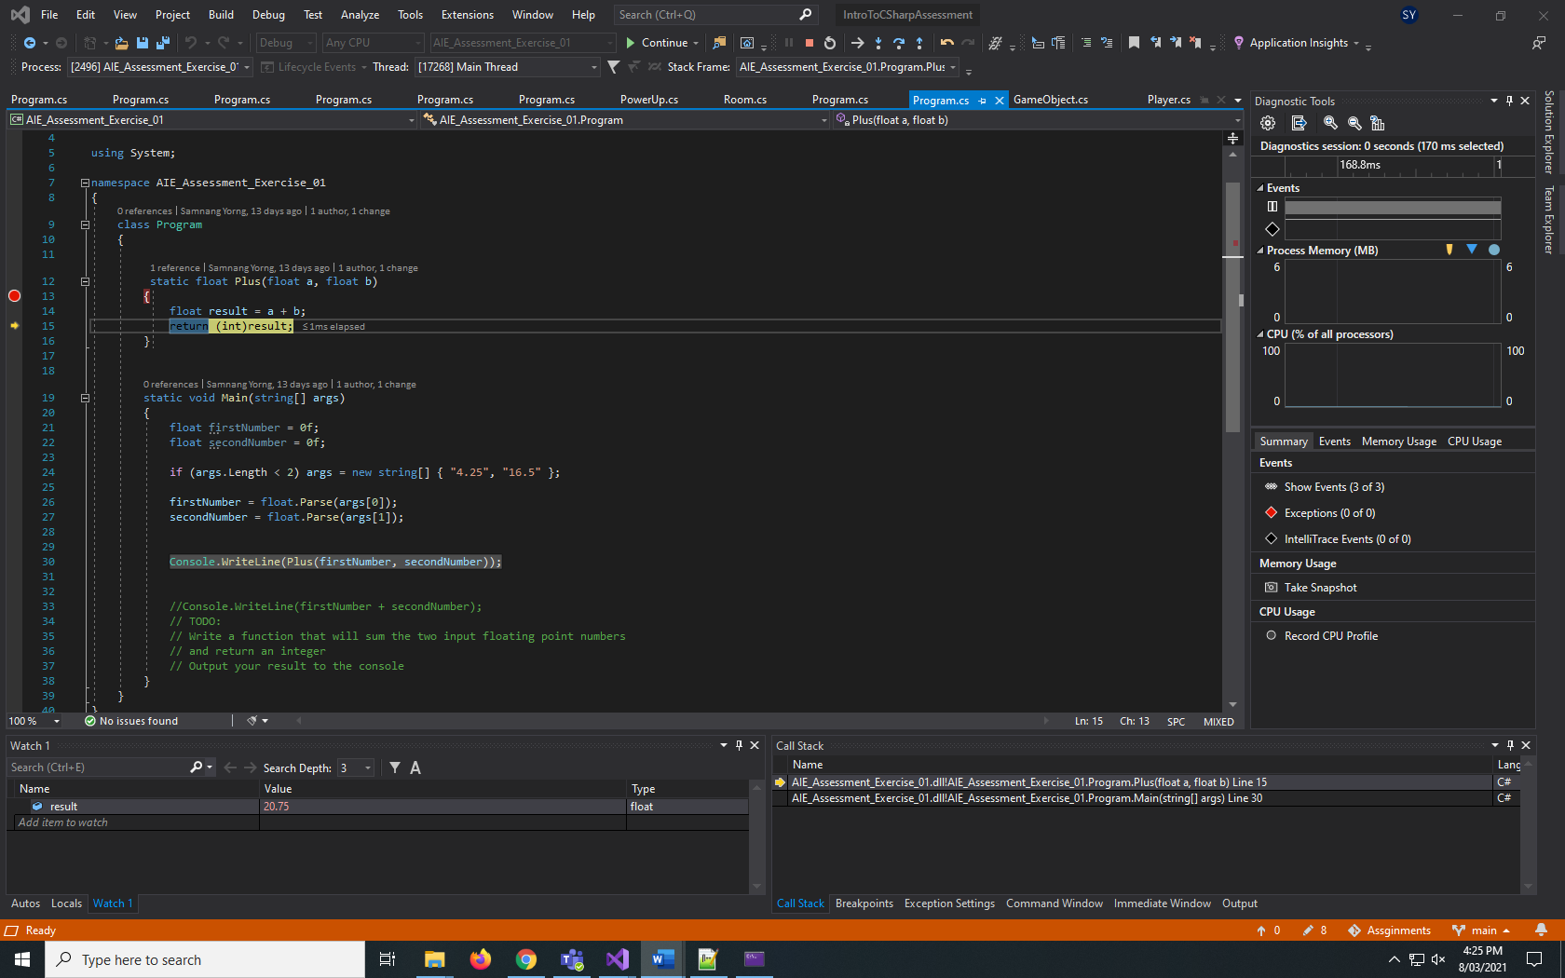

* A variable watch
* The call stack